Biography

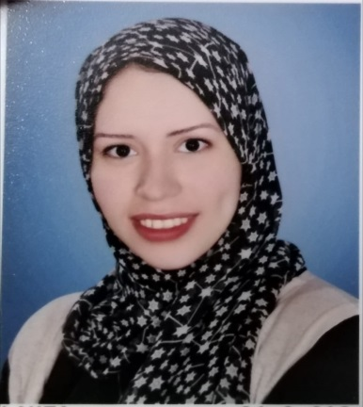
Samar Soliman KHalaf
Department of Pathology & Clinical Pathalogy Faculty of Veterinary Medicine Assuit University.
Personal Data :
Name : Samar Soliman Khalaf
Graduation Year : 2019
Study at : Faculty of Veterinary Medicine Assuit University.
Date of birth : 8\12\1995
Phone number : 01060744737 & 01099830770
Address : Assuit \ Mubark city
E-mail : samar_soliman@vet.aun.edu.eg
samar.soliman.se@gmail.com
# Working as: Demonstrator of Pathology department at Faculty of Veterinary Medicine Assuit
University.

# Teaching to undergraduate students >>>>> practical courses of general pathology, systemic pathology , special pathology & clinical pathology

# Training & courses :
The sixty-third session of university teacher preparation

The training course quality standards in the teaching process

The training course the behaviors of the profession

The training course is an effective management of time and work stress

The training course organizing scientific conferences

